Paper Title* (use style: paper title)

*Note: Sub-titles are not captured in Xplore and should not be used

line 1: 1st Given Name Surname   
line 2: *dept. name of organization   
(of Affiliation)*  
line 3: *name of organization   
(of Affiliation)*line 4: City, Country  
line 5: email address or ORCID

line 1: 2nd Given Name Surname  
line 2: *dept. name of organization   
(of Affiliation)*  
line 3: *name of organization   
(of Affiliation)*line 4: City, Country  
line 5: email address or ORCID

line 1: 3rd Given Name Surname  
line 2: *dept. name of organization   
(of Affiliation)*  
line 3: *name of organization   
(of Affiliation)*line 4: City, Country  
line 5: email address or ORCID

*Abstract*—

Keywords—NICU, Pain Scale, SSIM, PSNR, Correlation Coefficient, Grid search, SVM classification

# Introduction

# New-born babies who need intensive medical care are often put in a special area of the hospital called the neonatal intensive care unit (NICU). Babies which are born preterm or with any health disorders are placed in NICU to provide special care and monitor continuously. New-born infants are exposed to painful experiences that might increase their short- and long-term morbidity and mortality, in addition to being associated with neurological developmental disorders [1].Pain is an unpleasant emotion associated with actual or potential tissue damage. Accurate assessment of pain is vital to ensure the optimal effectiveness and safety of pain management therapy in neonates who experience pain during the course of their NICU stay [2]. Accurate pain measurements in infants are difficult to achieve. Pain in infants are measured through behavioral changes such as crying, facial expressions, body posture, and movements. These behavior depends on infant’s gestational age, and maturity. Cry characteristics are also not good indicators in preterm or acutely ill infants, as it is difficult for them to produce a robust cry. Pain scales such as neonatal infant pain scale (NIPS); neonatal facial coding system (NFCS); neonatal pain, agitation, and sedation scale(N-PASS); cry, required oxygen, increased vital signs, expression, sleeplessness scale (CRIES); COMFORT Scale; and DouleurAigue Nouveau-ne (DAN) scoring system are used for pain validation.[3]. Infants cannot express pain verbally, so this impossibility has created the necessity of using other media for its evaluation and detection. In this way, pain scales based on vital signals and facial changes have been created to evaluate the pain of neonates. [4]

1. RELATED WORK

Ana Martínez et al, proposed a study that uses an automatic pain detection system by means of image analysis. The algorithm uses different texture descriptors like Local Binary Patterns, Local Ternary Patterns and Radon Barcodes along with SVM classifier for classification. SVM classifies input image into pain and non-pain classes.[4]

Cheng Li1 et al, proposes a real time monitoring system of young infants The system consists of two components: expression classification and expression state stabilization using Faster R-CNN and Hidden Markov Model for different expression classifications and discomfort detection[5]

Yosi Kristian et al, proposed a study uses a number of features based on action units for pain classification among infants. Active shape modeling (ASM) is used to extract geometrical features and facial boundaries, local binary pattern is used to extract texture features. Multi stage SVM classifier is used for severe pain classification.[6]

Yue Sun et al, proposed an automatic and continuous system to identify discomfort in infants. Motion trajectories of image are estimated using optical flow. For each video motion acceleration rate and extract 18 time- and frequency-domain features characterizing motion patterns are calculated. SVM classifier is used to classify comfort and discomfort among infants.[7]

Ruicong Zhi et al proposed a study for the assessment of infant pain based on dynamic pain facial expressions and fusion scheme for automatic pain assessment in infants by combining temporal appearance facial features and temporal geometric facial features. The effects of various factors that influence pain reactivity in infants, such as individual variables of gestational age, gender, and race are investigated.SVM classifier is used for infant pain recognition.[8]

Lykele Hazelhoff et al proposed an automated video survey system for the detection of discomfort in newborn babies by analysis of their facial expression. Proposed algorithm automatically segments the face from the background and localizes the eye, eye-brow and mouth regions a hierarchical classifier is employed to distinguish between the states sleep, awake and discomfort.[9]

Yue Sun et al proposed a system for automatic discomfort detection in infants by analyzing infant’s facial expression. Deep convolution Neural Network based on DenseNet is employed. The performance of the deep-learning model is improved when using our proposed strategic fine-tuning involving pre-training with generic people pictures and dataset balancing combined with two-fold cross-validation.[10]

.

1. Materials of methods
   * 1. Dataset
2. The Infant COPE Database, contains 204 facial images of 26 neonates experiencing the pain of a heel lance and three nonpain stressors: transport from one crib to another (a stressor that triggers crying that is not in response to pain), an air stimulus on the nose (a stressor that provokes eye squeeze), and friction on the surface of the heel (a stressor that produces facial expressions of distress that are similar to the expressions of pain). In addition to these four facial displays, the database includes images of the neonates in the neutral state of rest.
3. The images selected for analysis are recorded from NICU at MSRTH using Wi-Fi camera and mobile camera. NICU includes both full term and preterm neonates with gestation age ranging from 28-37 weeks and with varied health conditions. Different activities of the baby are recorded which includes cries and sleep of the baby using Fingers 1080 Hi-Res Webcam Videos are recorded at a frame rate of 30 fps.

Table 1Details of preparatory database

|  |  |  |  |  |  |  |
| --- | --- | --- | --- | --- | --- | --- |
| Patient Id | Gender | Gest  week | Duration  (Min) | Frame rate | Camera used | Diagnosis |
| PTV001 | M | 34 | 04.09 | 30fps | Wifi cam | PT |
| PTV017 | M | 37 | 01.10 | 30fps | Mobile | PT/AGA |
| PTV018 | M | 28 | 03.39 | 30fps | Mobile | PT/AGA/RDS |
| PTV016 | M | 32 | 21.55 | 30fps | Wifi cam | PT |
| PTV015 | M | 32 | 03.00 | 30fps | Mobile | PT |
| FTV003 | M | 40 | 03.00 | 30fps | Mobile | SGA |
| FTV001 | M | 37 | 21.96 | 30fps | Wifi cam | AGA/MAS |
| FTV002 | M | 40 | 21.55 | 30fps | Wifi cam | AGA/ MSAF |

* + 1. Overall framework

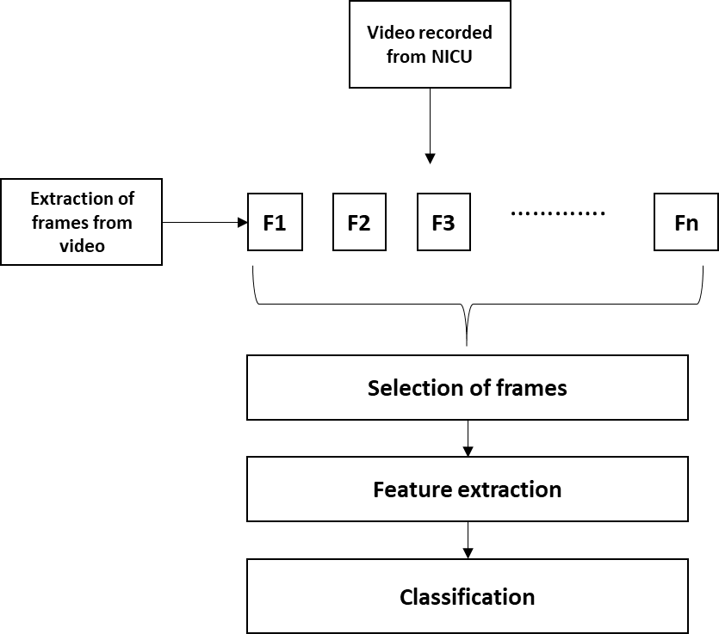

Figure 2 Proposed framework

* + 1. Selection of frames

For facial expression analysis, videos are first converted into frames. 20% of frames are taken for analysis. These frames are then selected based on following criteria

(a)Case A - Selecting Random frames -20% of frames are taken for analysis by considering first, mid and last frame.

(b) Case B- Selecting frames based on SSIM (Structural Similarity Index) values by varying threshold values. ‘I’ is taken as reference frame, SSIM is performed by varying threshold values (0.67, 0.77,0.87). 20 frames are selected.

(c)Case C- Selection based on Correlation.

(d)Case D –Selection based on PSNR values.

(e)Case E- Selecting all the frames.

* + 1. Feature extraction- Grid search

Grid-search is used to find the optimal hyper parameters of a model which results in the most accurate predictions

* + 1. Classifier- SVM classifier

The objective of the support vector machine algorithm is to find a hyperplane in an N-dimensional space (N — the number of features) that distinctly classifies the data points. Hyperplanes are decision boundaries that help classify the data points. Data points falling on either side of the hyperplane called as support vectors can be attributed to different classes.

The selection of the kernel depends on the application. Since the dataset is nonlinear we employ Gaussian kernel.

https://www.tandfonline.com/na101/home/literatum/publisher/tandf/journals/content/teta20/2016/teta20.v028.i01-02/0952813x.2015.1024491/20160302/images/teta_a_1024491_ilm0010.gif

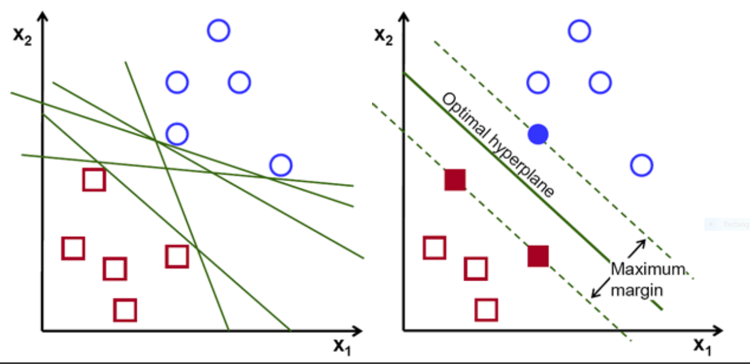

Figure 3 Hyper planes

1. **Results**
2. Binary classification- Categorized into pain and no pain classes. SVM has been trained with 70 pain images and 75 non-pain images, and the tests have been performed with 30 pain images and 25 non-pain images different from the training stage. The unbalanced number of images is due to the number of pictures of each class available in the database.

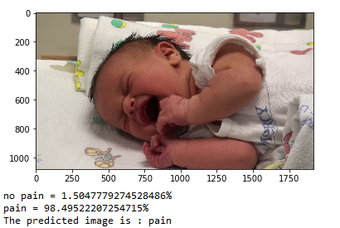

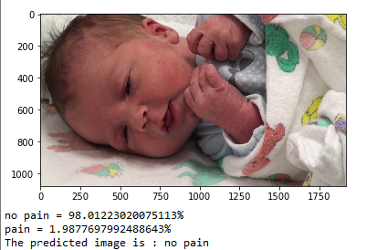

1. Multi class classification- Categorized into mild moderate and severe classes. 80 percent of data is used for training and 20% of data is used for testing.

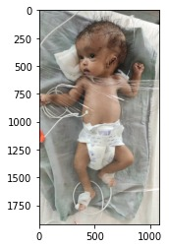

**moderate = 25.095100341583905%**

**None = 60.30653489330289%**

**severe = 14.598364765113189%**

**The predicted image is: None**

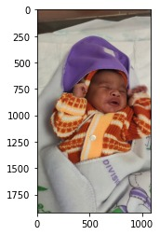

**moderate = 95.3253408163106%**

**None = 2.420899909551253%**

**severe = 2.2537592741381443%**

**The predicted image is: moderate**

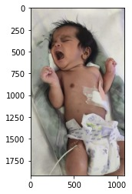

**moderate = 8.648209596205698%**

**None = 3.2216067411114846%**

**severe = 88.13018366268282%**

**The predicted image is: Severe**

* + 1. Evaluation matrix

|  |  |  |  |  |  |
| --- | --- | --- | --- | --- | --- |
|  | Case 1 | Case 2 | Case 3 | Case 4 | Case 5 |
| Accuracy | 0.96875 | 0.9578 | 0.956 | 0.9657 | 0.9621 |
| Sensitivity | 0.9375 | 0.926 | 0.9288 | 0.9348 | 0.93 |
| Specificity | 1 | 1 | 0.98 | 0.99 | 1 |
| F1 Score | 0.97 | 0.96 | 0.963 | 0.975 | 0.972 |

1. Performance evaluation

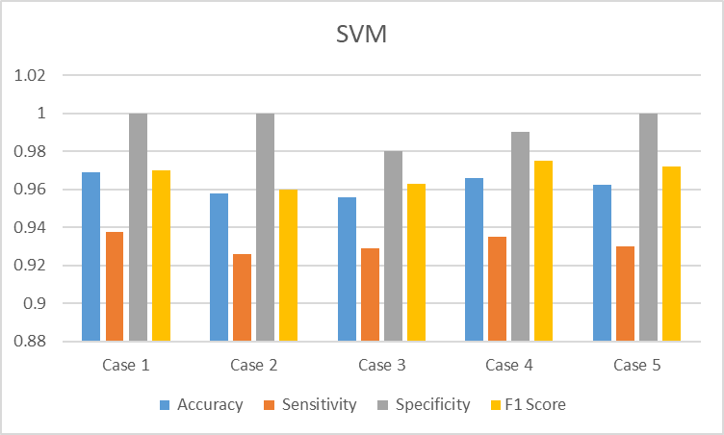

Figure: Evaluation matrix for multiclass SVM

1. Discussion

The videos of the neonates are recorded from NICU. Videos are converted to still frames. The best frames are selected using PSNR, SSIM and Correlation techniques. These images are

1. Conclusion

Acknowledgement

Conclusion

##### References

[1] T. M. Heiderich, A. Teresa, F. Stochero, and R. Guinsburg, “Neonatal procedural pain can be assessed by computer software that has good sensitivity and specificity to detect facial movements,” pp. 63–69, 2015, doi: 10.1111/apa.12861.

[2] L. G. Maxwell, M. V Fraga, and C. P. Malavolta, “Assessment of Pain in the N e w b o r n : An Update Neonate Pain Assessment Pain scales,” vol. 46, pp. 693–707, 2019, doi: 10.1016/j.clp.2019.08.005.

[3] R. Srouji, S. Ratnapalan, and S. Schneeweiss, “Pain in Children : Assessment and Nonpharmacological Management,” vol. 2010, 2010, doi: 10.1155/2010/474838.

[4] A. Martínez, F. A. Pujol, and H. Mora, “Application of texture descriptors to facial emotion recognition in infants,” *Appl. Sci.*, vol. 10, no. 3, 2020, doi: 10.3390/app10031115.

[5] C. Li, A. Pourtaherian, L. Van Onzenoort, and P. H. N. De With, “Automated infant monitoring based on R-CNN and HMM,” *VISIGRAPP 2021 - Proc. 16th Int. Jt. Conf. Comput. Vision, Imaging Comput. Graph. Theory Appl.*, vol. 5, no. Visigrapp, pp. 553–560, 2021, doi: 10.5220/0010299605530560.

[6] Y. Kristian *et al.*, “A Novel Approach on Infant Facial Pain Classification using Multi Stage Classifier and Geometrical-Textural Features Combination,” no. February, 2017.

[7] Y. Sun *et al.*, “Automatic and Continuous Discomfort Detection for Premature Infants in a NICU Using Video-Based Motion Analysis,” *Proc. Annu. Int. Conf. IEEE Eng. Med. Biol. Soc. EMBS*, pp. 5995–5999, 2019, doi: 10.1109/EMBC.2019.8857597.

[8] R. Zhi, G. Zamzmi, D. Goldgof, T. Ashmeade, and Y. Sun, “Automatic Infants ’ Pain Assessment by Dynamic Facial Representation : Effects of Profile View , Gestational Age , Gender , and Race,” pp. 1–16, doi: 10.3390/jcm7070173.

[9] L. Hazelhoff and J. Han, “Behavioral State Detection of Newborns Based,” pp. 698–709, 2009.

[10] A. Manuscript, “Ac ce d M us pt,” 2019.